
Solution User Diagram
HOT Architecture Documentation

This document provides an overview of a solution user diagram, then digs into the mechanics of creating one in LibreOffice. For a general overview of the technical documentation approach for HOT, check out the technical documentation Wiki at https://github.com/hotosm/techdoc/wiki.
When it comes to solution architecture, a solution user model is a visual representation of the users and the actions they will perform with a solution. The goal of this model is to understand and define the problem you’re trying to solve and to help maintain a people-centered perspective throughout the architecture process. A solution user diagram is often modeled using a box-oriented approach.
Table of Contents
Solution User Diagram HOT Architecture Documentation 1
What is a solution user model? 1
Box-Oriented Approach 2
Elements of the diagram! 2
Some Tips 3
Drawing with LibreOffice 3
Getting Started 3
Page Setup 3
Connecting Components 5
Clean Up 5

What is a solution user model?
From our friends at Architecture and Governance Magazine:
A solution user diagram is simple; it is barely a diagram. So, people can understand it or even create one with little or no training or prior experience. You create “user cards” with roles and list architecturally significant use cases on the cards.

From our friends at Wittij:

A solution user model, when implemented properly, can be useful in a variety of different areas:

- Create a basis off of which to agree on the scope when no requirements exist
- Understand a set of requirements and validate that understanding with others
- Ensure a solution architecture addresses all user needs
- Act as a first step to process design activities
- Identify the scope for anything involving people

Box-Oriented Approach
Given the simplicity of a solution user view, it can be modeled with virtually any tool. The idea is to create “playing cards” for each user that list the activities the user will need to perform with the solution.
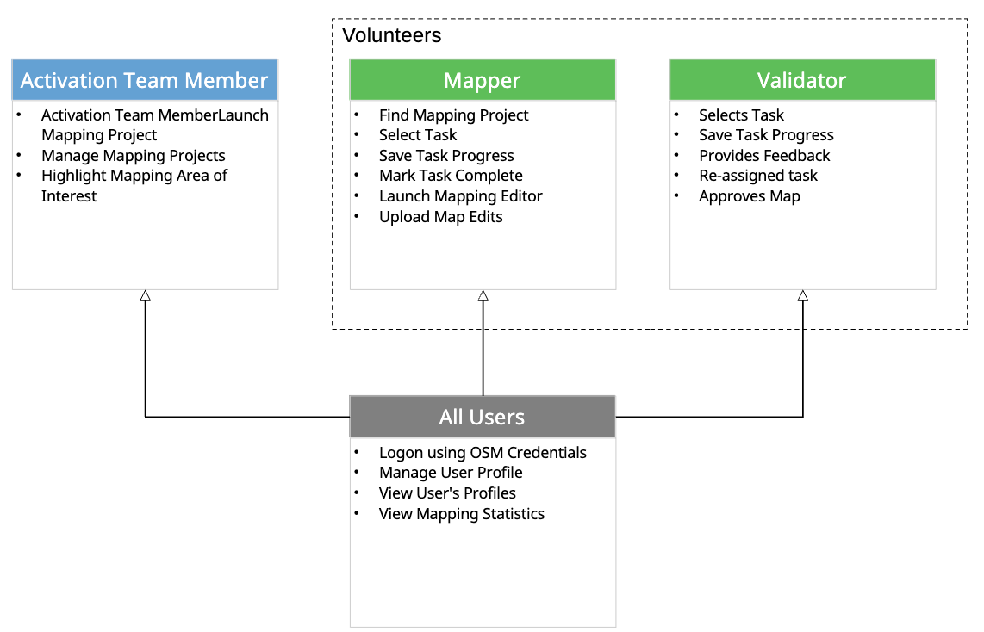

Elements of the diagram!
Here is a quick review of how to think about each element on the diagram:
- Each “playing card” on the diagram is made up of a box with two sections.
  - The top section acts as the header and contains the functional role of the user
  - The larger bottom section contains a bulleted list of all actions the user may perform. Utilize use case naming convention, VERB + NOUN, with as few additional modifiers as possible.
- Color the functional role boxes to group roles; such as internal vs. external or direct vs. indirect
- Group cards together using placement or labeled dotted boxes.
- Use dotted-line arrows to signify a transition from one role to another, labeling the line to indicate the specific transition
- Use open-head arrows to show that a role inherits all actions from another role
  - Use this sparingly. The goal is to make this diagram as simple as possible. Alternatively, the shared actions can be repeated in each card.

Some Tips
Before we get started on the mechanics, here are a few tips:
- This is intended to be a simple and concise view of the users and their actions.
  - Tradeoff completeness and details for clarity. Get it to where it gives someone (technical or non technical) an understanding of how each functional role will utilize the solution, then stop there.
- Keep all the boxes the same size. It makes your diagram look cleaner and more professional.
- Align boxes vertically and horizontally as much as feasible. It makes your diagram look cleaner and more professional.

Drawing with LibreOffice

Getting Started
This assumes you know how to use LibreOffice Draw and provides additional guidance to help you create this specific diagram in LibreOffice. Please checkout these resources to learn more about using LibreOffice:
- https://www.libreoffice.org/get-help/install-howto/
- https://documentation.libreoffice.org/
- https://documentation.libreoffice.org/assets/Uploads/Documentation/en/DG7.5/DG75-DrawGuide.pdf
- https://help.libreoffice.org/latest
It is also often quickest to grab an existing diagram and edit instead if starting from scratch. You can find an existing solution user diagram here: https://github.com/hotosm/techdoc/blob/main/templates/Solution%20User%20Template.odg
Otherwise, start by using the file menu to Create a New Drawing.

Page Setup
If you are not using an existing diagram to start, make a copy of the Solution User Diagram template and rename it to the name of your solution, e.g. “Tasking Manager Solution User Diagram.odg.”
Pro tip: In LibreOffice, the playing cards are created from two separate boxes. When copying and pasting from the template, make sure to select both boxes to add a new playing card.

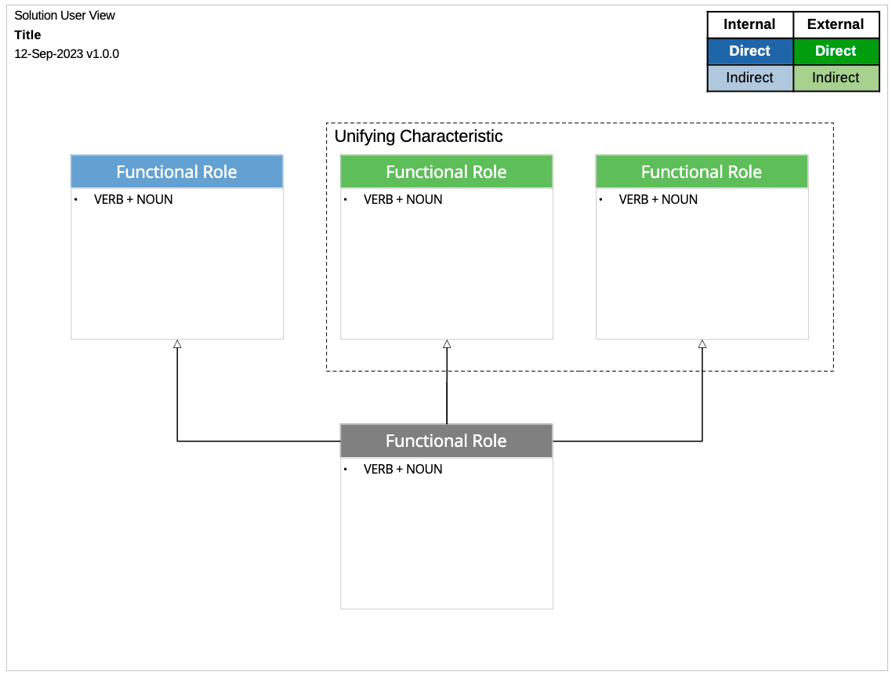
In the upper left, is our standard title block. Change the word “title” to the title of your diagram. It should describe the scope of your diagram. For example, “Tasking Manager.”

Alternative Approach...
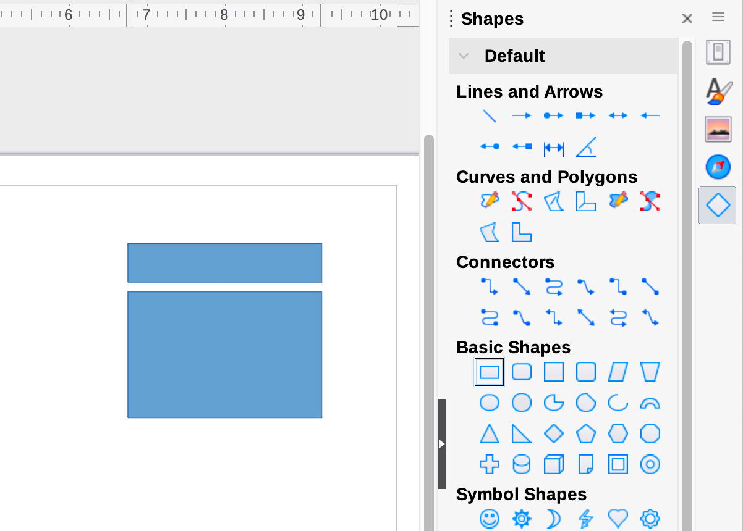
To create a new playing card, without copying an existing template, select the rectangle from the “Shapes” tab on the righthand side. Then, on the page, use your mouse to click and hold to create your desired rectangle shape. Once you’ve created one box of the playing card, repeat the process to create the second box of your playing card.
Click each rectangle and use the “Properties” tab to change the fill color and line color, if necessary. In the paragraph section, for the larger “actions” box, change to left and top alignment. Double click in the box to bring up the lists section and select small bullets. Click and drag the boxes to line up the top of the large box with the bottom of the smaller top box.
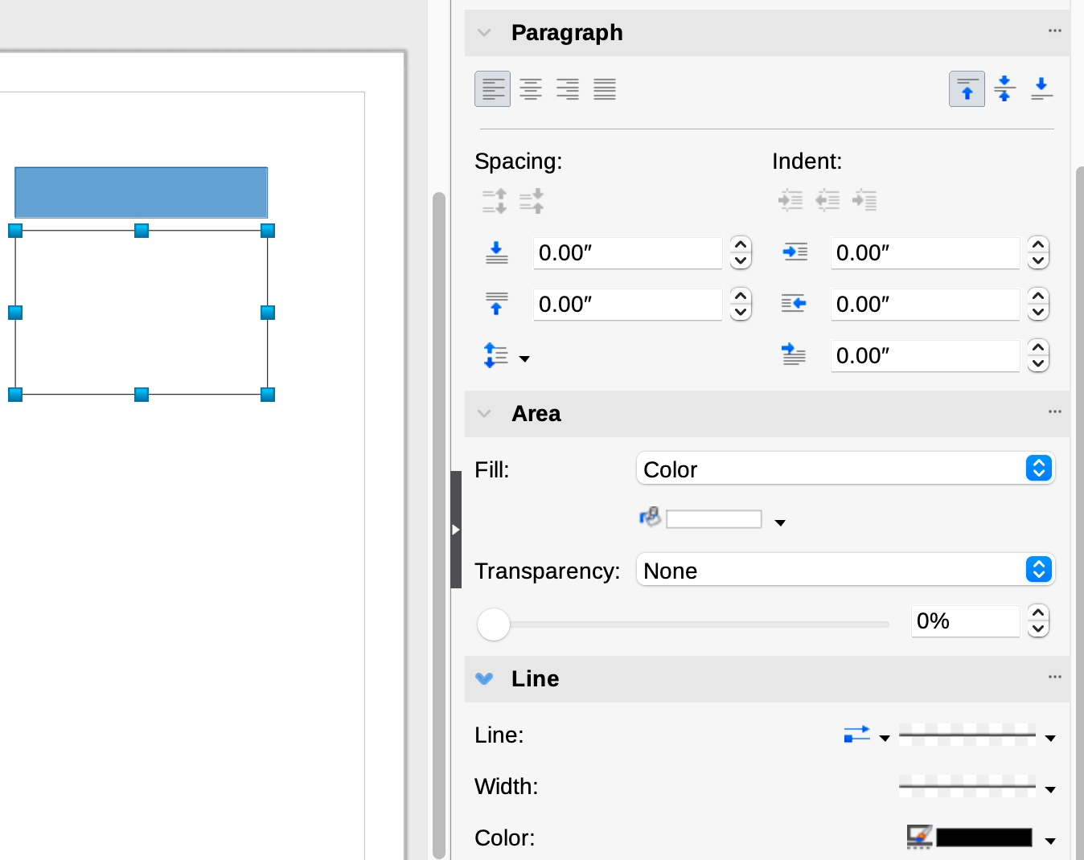
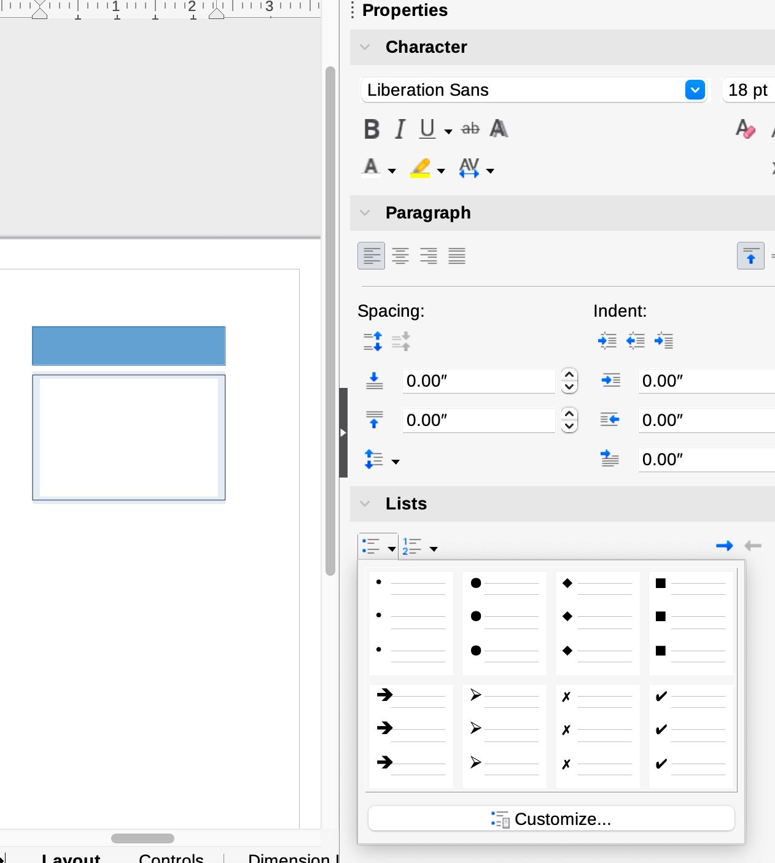

Connecting Components
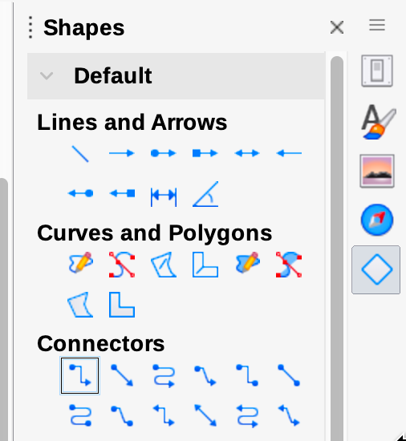
Once you have some playing cards added to the diagram, you can choose between the connectors listed in the “Shapes” tab on the righthand side, then hover over any component. The connectors will appear on the component you are hovering over.
Click on any connector and, holding the mouse button down, move the mouse over the other shape you would like to connect. Release the mouse button when it is hovering over one of the connectors on the other component.
You can select any connector on the diagram and use the “Properties” tab on the righthand side to fix the connection style:
- Increase the thickness of the line to 1.0 pt and change the color to black.
- Change the line arrow to an open-head point to show a role inheriting actions from another role.
  - To show a transition from one role to another, change the arrow line to be dotted.
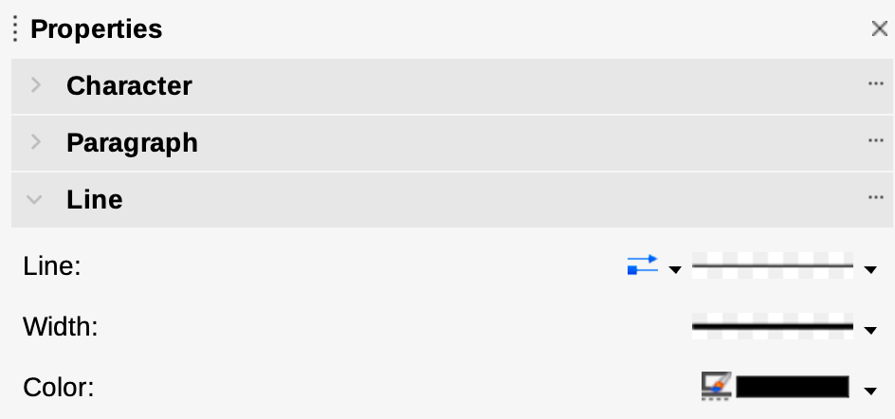

Line Arrows
Line Style →
Line Thickness →
Line Color →

Pro tip: If you select the correct Line attributes with no connector selected, it will become your default for all future connectors.

Clean Up
Once you have your whole diagram laid out, select each playing card and use the right-click “align” function to get them all in alignment accordingly.

https://www.architectureandgovernance.com/applications-technology/solution-architecture-diagramming/
https://wittij.com/solution-user-diagram-for-rapid-scoping/
Scott Ambler’s book “Elements of UML Style 2.0” has some great general diagramming tips.

